2019 Year 11 Physics

Marks / 47

Name: ________________

End of unit test

Electricity.

Short answer section – 33 marks

1. (3 marks)

Compare and contrast two different electrical safety devices used in the home and state the effectiveness in different situations.

1. (3 marks)

## Which of the following voltage – current graphs best represents a non-ohmic conductor? (1 mark)

**A B C D**

## Why did you select this graph? (2 marks)

1. (1 mark)

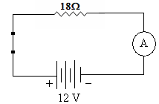Label the following circuit to show the direction of **electron** current.

1. (4 marks)

A lightning bolt contains 6.0 x 109 J of energy, which is enough to power a city. If it transfers 30 C of charge to the Earth in 1.5 ms.

## What was the potential difference produced by the lightning bolt? (2 marks)

## What is the average power dissipated during the strike? (2 marks)

1. (4 marks)

A rechargeable battery was charged at a constant current of 600 mA for 9 hours. The average cell potential difference during the re-charge was 1.6V.

## Calculate the amount of charge that passed through the cell (2 marks)

## Calculate the amount of work done by the charging device. (2 marks)

1. (3 marks)

A student completes a circuit that includes a mystery box as shown below.

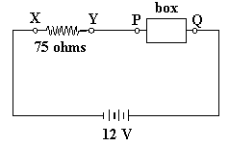

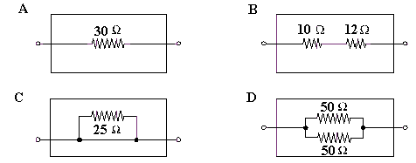If the potential difference between X and Y is 9.0 volts, which of the following boxes (A - D) is in the circuit? **For full marks, show working below.**

Answer:

1. (4 marks)

The element of an electric jug has a resistance of 60.0 Ω and draws a current of 3.75 A, there is 1.05 kg of water at a temperature of 20°C is in the jug. How long will it take to bring the water to the boil (100°C)? Give your answer in **minutes**.

1. (2 marks)

You are given the following components.

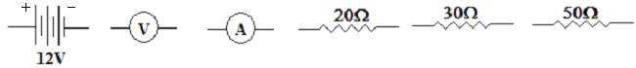

*Read all the instructions before you draw the circuit.*

Use these components to draw an electrical circuit where the 30Ω and 20Ω resistors are in series. Place the 50Ω resistor in parallel with both of these resistors. Place the voltmeter to measure the potential difference of the 30Ω resistor only and the ammeter to measure the current of the 20Ω resistor only. The battery supplies energy to the whole circuit.

1. (9 marks)

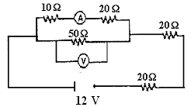A student has set up the following circuit in a practical examination.

Solve the following three questions and write your answers in the spaces provided:

## Determine the total resistance of the circuit: Answer: _____________ (3 marks)

## What is the reading on the voltmeter? Answer: _____________ (3 marks)

## What is the reading on the ammeter? Answer: _____________ (3 marks)

**Comprehension section – 14 marks**

When estimating numerical answers, show your working or reasoning clearly. Include appropriate units.

1. (14 marks)

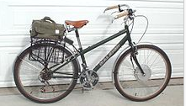 Cycling is good for the environment and your health but sometimes you may need a little help. That is the reason there has been an increase in the sale of electric bicycles, particularly to more elderly people. An **electric bicycle**, also known as an **e-bike**, is a [bicycle](http://en.wikipedia.org/wiki/Bicycle) with an integrated [electric motor](http://en.wikipedia.org/wiki/Electric_motor) that can be used for propulsion. There is a great variety of different types of e-bikes available in Australia, from e-bikes that only have a small motor to assist the rider's pedal-power (i.e. [pedelecs](http://en.wikipedia.org/wiki/Pedelec)) to somewhat more powerful e-bikes which tend closer to motor bike style functionality. All however retain the ability to be [pedalled](http://en.wikipedia.org/wiki/Bicycle_pedal) by the rider and are therefore not [electric motorcycles](http://en.wikipedia.org/wiki/Electric_motorcycles). E-bikes use rechargeable batteries and the lighter models can travel up to 25 - 32 km /h, depending on the laws of the country in which they are sold, while high-powered models can often travel a lot faster.

E-bikes typically have a 200 W motor, powered by a 36 V, 10 Ah (amp hour) lithium ion battery pack that can be recharged from 240 V mains supply using a transformer.

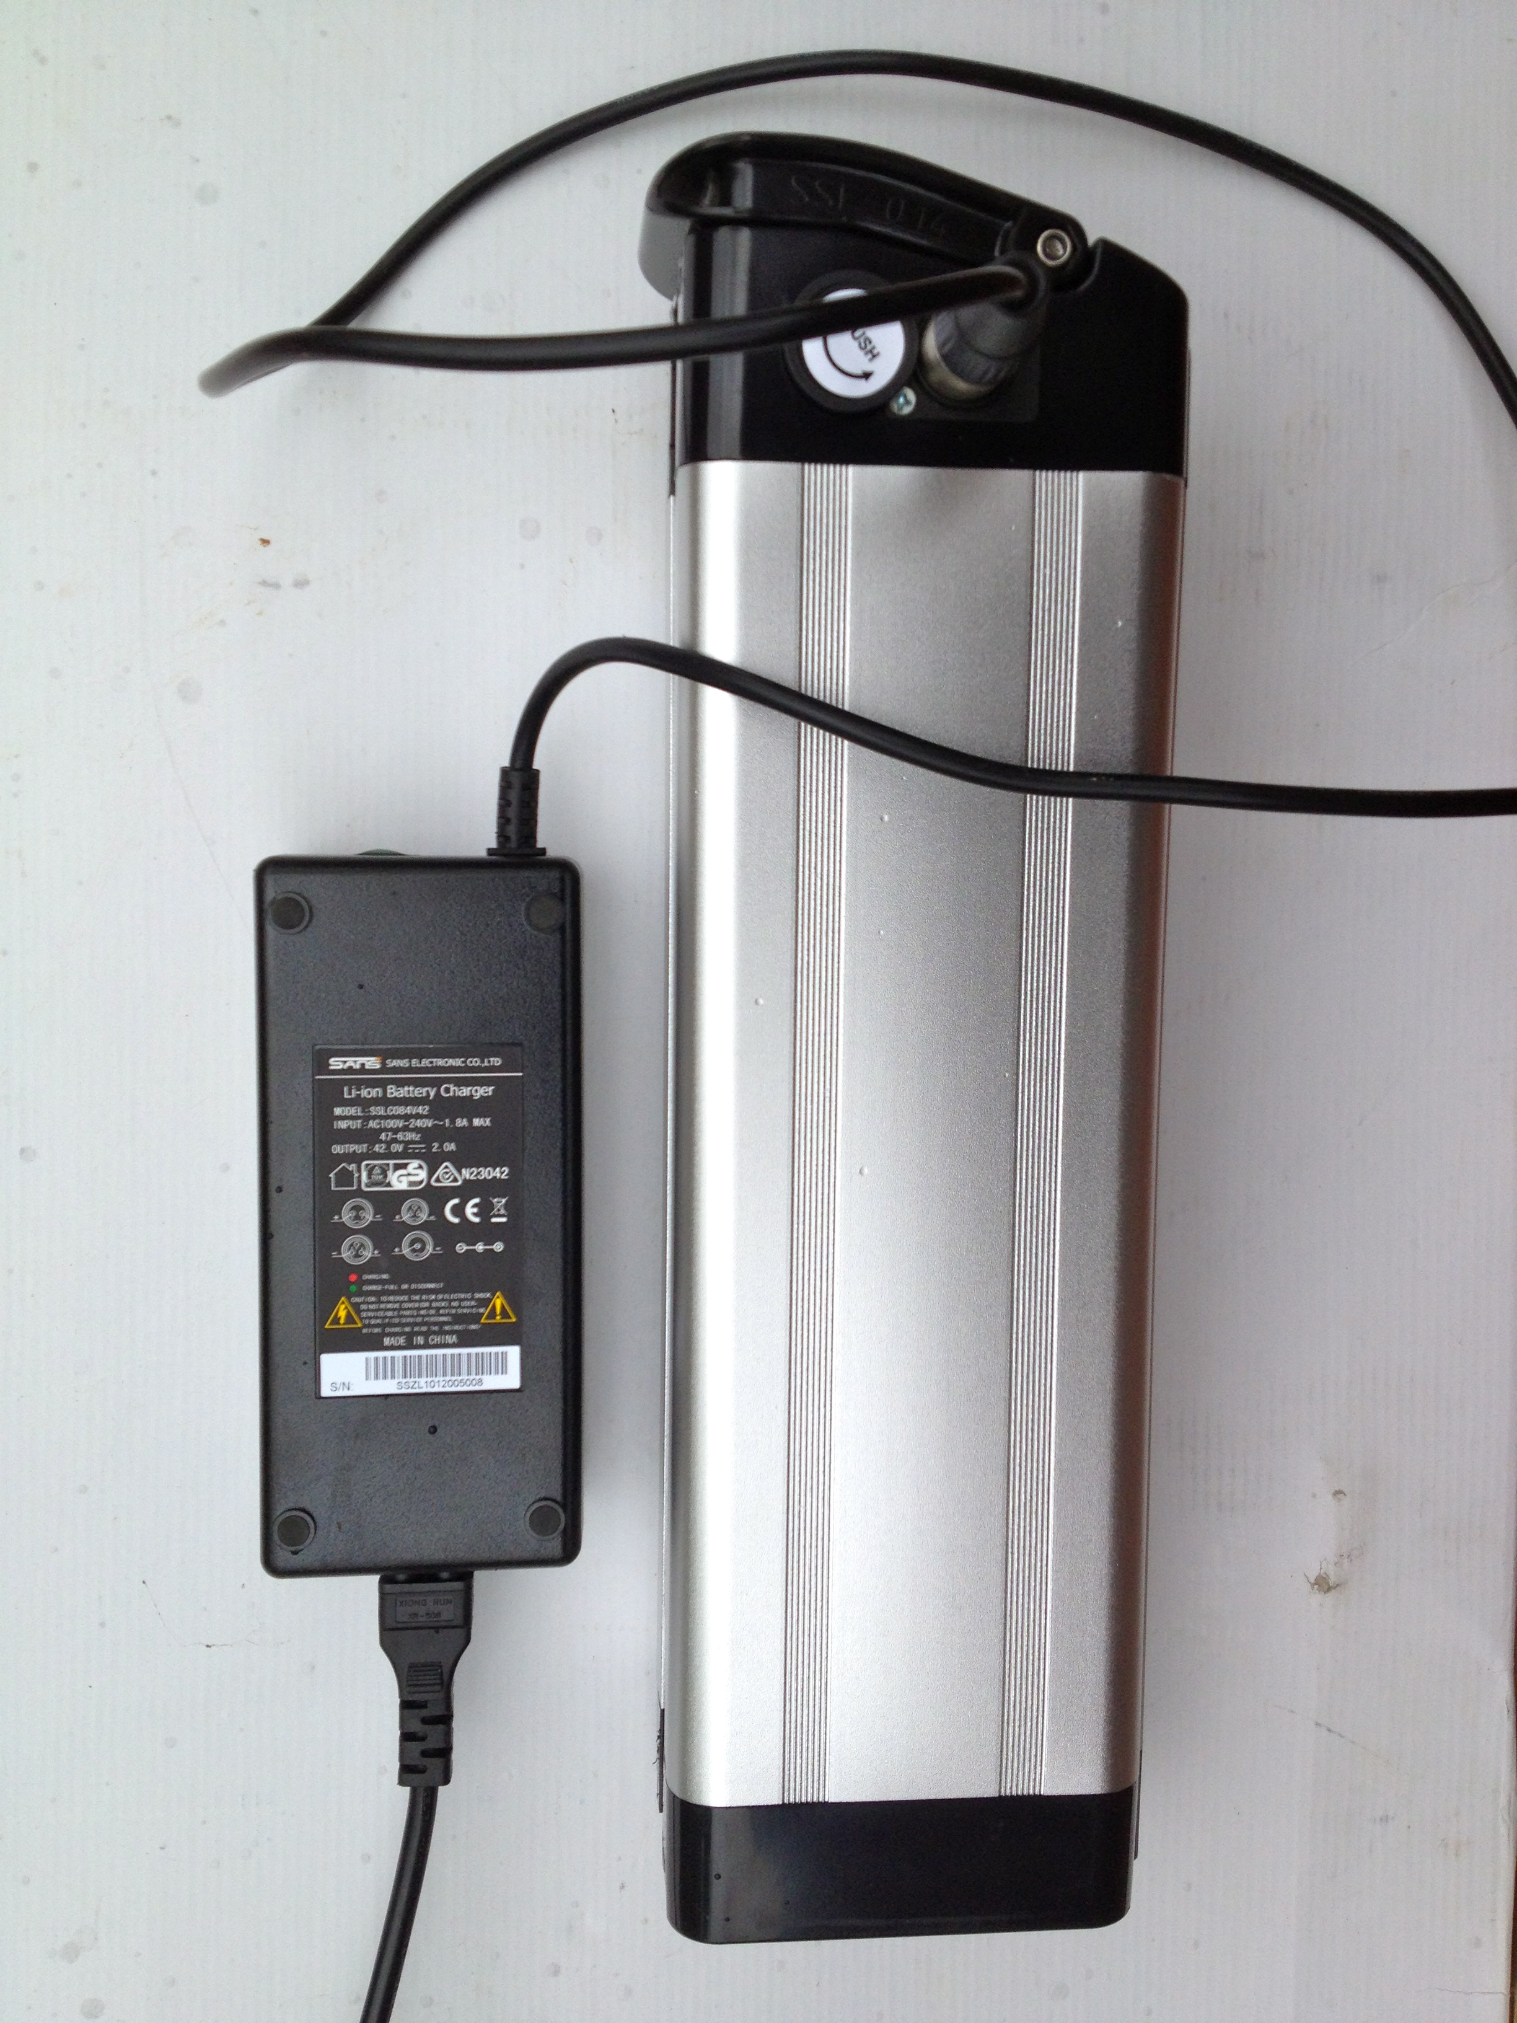The distance they can travel on a fully charged battery depends on whether you use the ‘pedal assist’ function. That means you can extend the range by pedaling at the same time as using the electric motor.

Travelling on a flat, sealed road surface the battery will take you about 60 km without pedaling. If on the other hand you use the pedal assist function the range can be extended to 100 km. Compared to a carbon frame racing bike at about 7.0 kg, the typical e-bike, at 25 kg is not the lightest option to pedal. However, the mass disadvantage is compensated for by ease of operation.

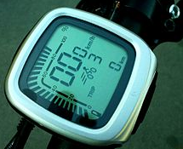 An integrated computer attached to the handlebars conveys information to the rider about distance travelled, speed, battery charge and projected range. Using this data the rider can make decisions about how likely they will be able to reach their destination!!

## In what way are e-bikes ‘good for the environment’? (2 marks)

## In what way are e-bikes ‘good for your health’? (2 marks)

## If the e-bike’s 200 W electric motor is working at its stated power, calculate the current it would be drawing from the lithium ion battery. (2 marks)

## Amp hours (Ah), when applied to batteries, provides an approximate indication of how long a battery is capable of delivering a particular current (A). For instance a battery rated at 10 Ah could deliver 5A for 2 hours when connected to an appliance. If the typical e-bike described in the article, draws 3A on a ride, calculate how long the battery will deliver enough power to propel the bike. (2 marks)

## Explain what would happen to the power output of the motor when the rider was using the pedal assist function and how would this change the distance the rider could travel. (2 marks)

## After a ride the cyclist discovers the battery is completely discharged. If the battery is connected to a 36 V charger that delivers a steady current of 2.0 A to the battery for 2.0 hours, calculate the quantity of charge that is delivered to the battery. (2 marks)

## Estimate the electrical resistance in the e-bike electrical system when the 200 W motor is being driven by its 10 Ah battery. (2 marks)